**COMP215 Project Report**

Made by: Mohamad Hazim ID: 202100107

Mohamad Seif El Dine ID: 202101418

Georges Skaf ID: 202102931

------------------------------------------------------------------------------------------------------------------------------------------

The objective of our code is to show a restaurant

Management system that is divided into 2 sections:

Normal and VIP, Showing each sections their pros

And how they differ from each other.

**------------------------------------------------------------------------------------------------------------------------------------------**

1st: Random numbers

We used random numbers in the VIP Musical sections to vote generate thet total votes to your favorite Musicians

**------------------------------------------------------------------------------------------------------------------------------------------**2nd : Lists

We used it in the VIP section for each Menu (Lebanese ,American ,Italian,&French)

**------------------------------------------------------------------------------------------------------------------------------------------**

3rd : Tupples

We used it in the VIP section of the musicians to enter the musician names.

**------------------------------------------------------------------------------------------------------------------------------------------**

4th : Dictionaries

We used it in the normal section to enter the normal menu (Appetizers, drinks main plates)

**------------------------------------------------------------------------------------------------------------------------------------------**5th : GUI

We used GUI , to sign up to your account in the gaming lounge.

**------------------------------------------------------------------------------------------------------------------------------------------**

6th : File Processing

Weused it in the VIP gaming lounge section

**------------------------------------------------------------------------------------------------------------------------------------------**

**Some Output Pictures:**

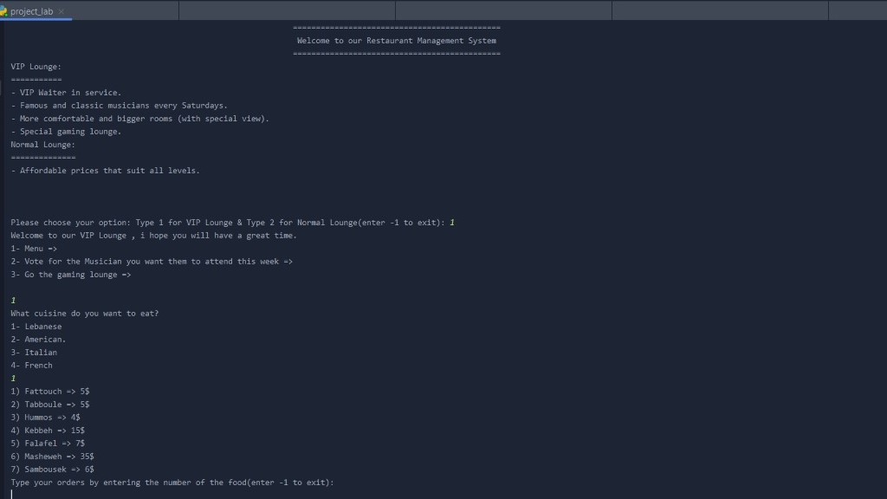

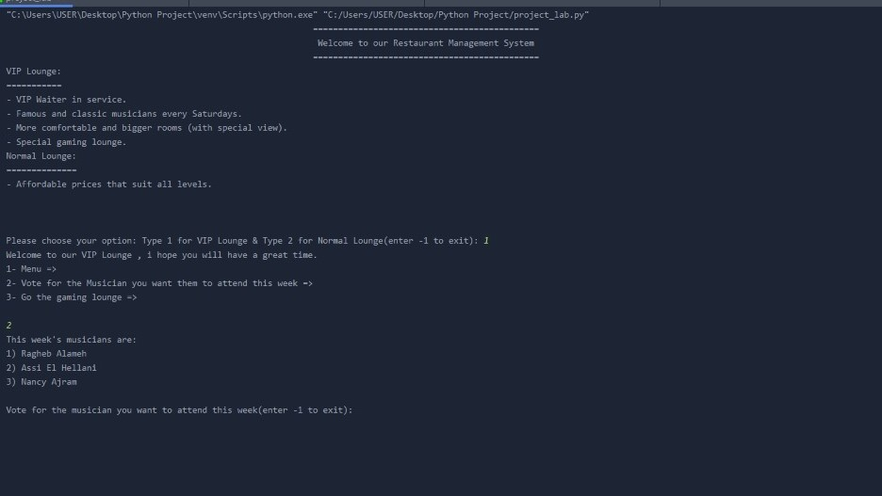

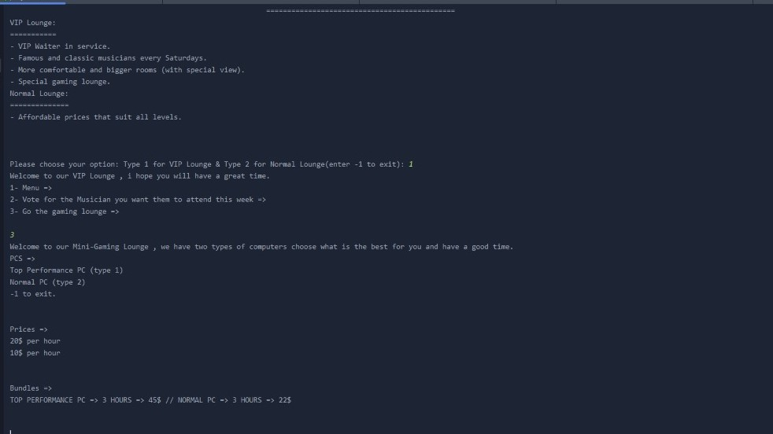

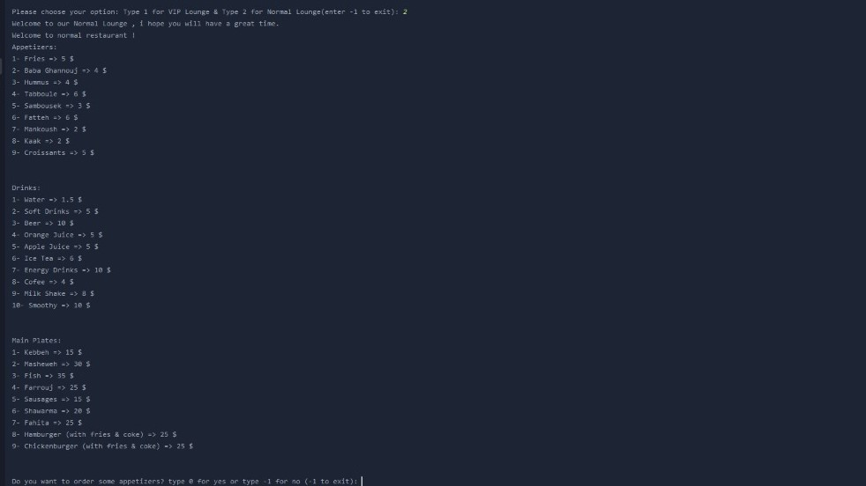

**What could we do to improve our project**?

1st: Virtual Calculator to calculate prices using gui

2nd: AI that could transfer you to the reservation system

3rd : AI that respond to phone calls and talk to people(High level of artificial intelligence)

4th : A system for takeaways

5th: Login in the account in the gaming lounge to display the hours remaining & more details in the lounge.

------------------------------------------------------------------------------------------------------------------------------------------

**Python Source Code:**

import random

from tkinter import *

print("\t\t\t\t\t\t\t\t\t\t\t\t\t\t\t =============================================")

print("\t\t\t\t\t\t\t\t\t\t\t\t\t\t\t Welcome to our Restaurant Management System")

print("\t\t\t\t\t\t\t\t\t\t\t\t\t\t\t =============================================")

print("VIP Lounge:\n===========\n- VIP Waiter in service.\n- Famous and classic musicians every Saturdays.\n- More comfortable and bigger rooms (with special view).\n- Special gaming lounge.")

print("Normal Lounge:\n==============\n- Affordable prices that suit all levels.\n\n\n")

price = 0

def gaming_lounge():

import tkinter as t

r = t.Tk()

r.title('Gaming lounge Register Page')

Label(r, text='First Name').grid(row=0)

Label(r, text='Last Name').grid(row=1)

Label(r, text='enter account username').grid(row=2)

Label(r, text='enter account password').grid(row=3)

e1 = Entry(r)

e2 = Entry(r)

e3 = Entry(r)

e4 = Entry(r)

e1.grid(row=0, column=1)

e2.grid(row=1, column=1)

e3.grid(row=2, column=1)

e4.grid(row=3, column=1)

r.geometry("200x100")

button2 = t.Button(r, text='Register', width=80, command=r.destroy)

button2.grid()

r.mainloop()

print("Welcome to our Mini-Gaming Lounge , we have two types of computers choose what is the best for you and have a good time.")

print("PCS =>")

GamingLounge=[]

file=open("GamingLounge.txt","r")

for i in file:

high,end = i.split("|",6)

GamingLounge1=[high,end]

GamingLounge += GamingLounge1

file.close()

print(GamingLounge[0],GamingLounge[1],end="\n")

print("Prices:")

PRLCE = []

file=open("PRICES.txt","r")

for j in file:

high,end=j.split("|",2)

PRLCE1=[high,end]

PRLCE += PRLCE1

file.close()

print(PRLCE[0],PRLCE[1])

print("Bundles:")

BUNDLES = []

file=open("BUNDLES.txt","r")

for z in file:

high,end=z.split("|",2)

BUNDLES1=[high,end]

BUNDLES += BUNDLES1

file.close()

print(BUNDLES[0],BUNDLES1[1])

pc_price = 0

game_ans = int(input())

if (game_ans) == 1:

top_pc=int(input("Choose if you want our bundle(type 1) or recharge normally (type 2)"))

if top_pc == 1:

pc_price += 45

print("The total cost is: ", pc_price,"$")

elif top_pc == 2:

hours = int(input("How many hours do you want to recharge?"))

pc_price = 20 * hours

print("The total cost is: ", pc_price,"$")

else:

print("Invalid Input")

print("Choose if you want our bundle(type 1) or recharge normally (type 2).")

game_ans = int(input())

gaming_lounge()

elif game_ans ==2:

nor_pc = int(input("Choose if you want our bundle(type 1) or recharge normally (type 2)."))

if nor_pc == 1:

pc_price += 22

print("The total cost is : ", pc_price, "$")

elif nor_pc == 2:

hours = int(input("How many hours do you want to recharge?"))

pc_price += 10 * hours

print("The total cost is: ", pc_price, "$")

else:

print("Invalid input , please try again.")

gaming_lounge()

elif game_ans == -1:

exit()

else:

print("Invalid Input , please try again.")

gaming_lounge()

def normal_rest():

tot_price = 0

print("Welcome to normal restaurant !")

Normal_Menu1 = {"Fries": 5, "Baba Ghannouj": 4, "Hummus": 4, "Tabboule": 6, "Sambousek": 3, "Fatteh": 6,

"Mankoush": 2, "Kaak": 2, "Croissants": 5}

a = 1

print("Appetizers:")

for items, price in Normal_Menu1.items():

print("%d-" % (a), items, "=>", price, "$")

a += 1

print("\n")

Normal_Menu2 = {"Water": 1.5, "Soft Drinks": 5, "Beer": 10, "Orange Juice": 5, "Apple Juice": 5, "Ice Tea": 6,

"Energy Drinks": 10, "Cofee": 4, "Milk Shake": 8, "Smoothy": 10}

b = 1

print("Drinks:")

for items, price in Normal_Menu2.items():

print("%d-" % (b), items, "=>", price, "$")

b += 1

print("\n")

c = 1

print("Main Plates:")

Normal_Menu3 = {"Kebbeh": 15, "Masheweh": 30, "Fish": 35, "Farrouj": 25, "Sausages": 15, "Shawarma": 20,

"Fahita": 25, "Hamburger (with fries & coke)": 25, "Chickenburger (with fries & coke)": 25}

for items, price in Normal_Menu3.items():

print("%d-" % (c), items, "=>", price, "$")

c += 1

print("\n")

nor_app = int(input(("Do you want to order some appetizers? type 0 for yes or type -1 for no (-1 to exit): ")))

while nor_app != -1:

if nor_app == 0:

print("Choose your order")

nor_app = int(input(("Choose your order (-1 to exit): ")))

if nor_app == 1:

print("Successfully Added")

tot_price += 5

nor_app = int(input(("Choose your order (-1 to exit): ")))

elif nor_app == 2:

print("Successfully Added")

tot_price += 4

nor_app = int(input(("Choose your order (-1 to exit): ")))

elif nor_app == 3:

print("Successfully Added")

tot_price += 4

nor_app = int(input(("Choose your order (-1 to exit): ")))

elif nor_app == 4:

print("Successfully Added")

tot_price += 6

nor_app = int(input(("Choose your order (-1 to exit): ")))

elif nor_app == 5:

print("Successfully Added")

tot_price += 3

nor_app = int(input(("Choose your order (-1 to exit): ")))

elif nor_app == 6:

print("Successfully Added")

tot_price += 6

nor_app = int(input(("Choose your order (-1 to exit): ")))

elif nor_app == 7:

print("Successfully Added")

tot_price += 2

nor_app = int(input(("Choose your order (-1 to exit): ")))

elif nor_app == 8:

print("Successfully Added")

tot_price += 2

nor_app = int(input(("Choose your order (-1 to exit): ")))

elif nor_app == 9:

print("Successfully Added")

tot_price += 5

nor_app = int(input(("Choose your order (-1 to exit): ")))

else:

print("Invalid Input")

nor_app = int(input(("Choose your order (-1 to exit): ")))

print("The total price of your order till now is: ", tot_price, "$\n\n")

nor_app_1 = int(input(("Do you want any drinks ? if yes type 0 & if no type -1")))

while nor_app_1 != -1:

if nor_app_1 == 0:

print("Choose your order")

nor_app_1 = int(input(("Choose your order (-1 to exit): ")))

if nor_app_1 == 1:

print("Successfully Added")

tot_price += 1.5

nor_app_1 = int(input(("Choose your order (-1 to exit): ")))

elif nor_app_1 == 2:

print("Successfully Added")

tot_price += 5

nor_app_1 = int(input(("Choose your order (-1 to exit): ")))

elif nor_app_1 == 3:

print("Successfully Added")

tot_price += 10

nor_app_1 = int(input(("Choose your order (-1 to exit): ")))

elif nor_app_1 == 4:

print("Successfully Added")

tot_price += 5

nor_app_1 = int(input(("Choose your order (-1 to exit): ")))

elif nor_app_1 == 5:

print("Successfully Added")

tot_price += 5

nor_app_1 = int(input(("Choose your order (-1 to exit): ")))

elif nor_app_1 == 6:

print("Successfully Added")

tot_price += 6

nor_app_1 = int(input(("Choose your order (-1 to exit): ")))

elif nor_app_1 == 7:

print("Successfully Added")

tot_price += 10

nor_app_1 = int(input(("Choose your order (-1 to exit): ")))

elif nor_app_1 == 8:

print("Successfully Added")

tot_price += 4

nor_app_1 = int(input(("Choose your order (-1 to exit): ")))

elif nor_app_1 == 9:

print("Successfully Added")

tot_price += 8

nor_app_1 = int(input(("Choose your order (-1 to exit): ")))

elif nor_app_1 == 10:

print("Successfully Added")

tot_price += 10

nor_app_1 = int(input(("Choose your order (-1 to exit): ")))

else:

print("Invalid Input")

nor_app_1 = int(input(("Choose your order (-1 to exit): ")))

print("The total price of your order till now is: ", tot_price, "$\n\n")

nor_app_2 = int(input("Do you want any main plats ? if yes type 0 & if no type -1."))

while nor_app_2 != -1:

if nor_app_2 == 0:

nor_app_2 = int(input("Choose your order (-1 to exit): "))

if nor_app_2 == 1:

print("Succesfully Added")

tot_price += 15

nor_app_2 = int(input(("Choose your order (-1 to exit): ")))

elif nor_app_2 == 2:

print("Succesfully Added")

tot_price += 30

nor_app_2 = int(input(("Choose your order (-1 to exit): ")))

elif nor_app_2 == 3:

print("Succesfully Added")

tot_price += 35

nor_app_2 = int(input(("Choose your order (-1 to exit): ")))

elif nor_app_2 == 4:

print("Succesfully Added")

tot_price += 25

nor_app_2 = int(input(("Choose your order (-1 to exit): ")))

elif nor_app_2 == 5:

print("Succesfully Added")

tot_price += 15

nor_app_2 = int(input(("Choose your order (-1 to exit): ")))

elif nor_app_2 == 6:

print("Succesfully Added")

tot_price += 20

nor_app_2 = int(input(("Choose your order (-1 to exit): ")))

elif nor_app_2 == 7:

print("Succesfully Added")

tot_price += 25

nor_app_2 = int(input(("Choose your order (-1 to exit): ")))

elif nor_app_2 == 8:

print("Succesfully Added")

tot_price += 25

nor_app_2 = int(input(("Choose your order (-1 to exit): ")))

elif nor_app_2 == 9:

print("Succesfully Added")

tot_price += 25

nor_app_2 = int(input(("Choose your order (-1 to exit): ")))

else:

print("Invalid Input , please try again.")

nor_app_2 = int(input(("Choose your order (-1 to exit): ")))

print("The total price of your order till now is: ", tot_price, "$\n\n")

print("Do you want to order more? if yes type 1 and if no type 2")

nor_app = int(input())

if nor_app ==1 :

normal_rest()

elif nor_app ==2:

if (tot_price <= 20):

print("Thank you ! Your order will take 10 minutes ... Please be patient and have a good time")

exit()

elif 20<tot_price<=40:

print("Thank you ! Your order will take 22 minutes ... Please be patient and have a good time")

exit()

elif 40<tot_price<60:

print("Thank you ! Your order will take 35 minutes ... Please be patient and have a good time")

exit()

elif tot_price>60:

print("Thank you ! Your order will take up to 40 minutes ... Please be patient and have a good time")

exit()

else:

print("Invalid Input , please try again ...")

nor_app = int(input())

ans=int(input("Please choose your option: Type 1 for VIP Lounge & Type 2 for Normal Lounge(enter -1 to exit): "))

while ans != -1:

if ans == 1:

print("Welcome to our VIP Lounge , i hope you will have a great time.")

elif ans == 2:

print("Welcome to our Normal Lounge , i hope you will have a great time.")

else:

print("Invalid Input, please try again.")

ans = int(input("Please choose your option: Type 1 for VIP Lounge & Type 2 for Normal Lounge(enter -1 to exit): "))

if ans == 1 :

print("1- Menu =>\n2- Vote for the Musician you want them to attend this week =>\n3- Go the gaming lounge =>\n")

ans1=int(input())

if ans1==1:

print("What cuisine do you want to eat?\n1- Lebanese\n2- American.\n3- Italian\n4- French")

ans2 = int(input())

if ans2==1:

lebanese=["1) Fattouch => 5$ ","2) Tabboule => 5$","3) Hummos => 4$","4) Kebbeh => 15$","5) Falafel => 7$","6) Masheweh => 35$","7) Sambousek => 6$"]

for i in lebanese:

print(i)

print("Type your orders by entering the number of the food(enter -1 to exit): ")

answ=int(input())

while answ != -1:

if answ == 1:

print("Type the amount of plates you want: ")

i = int(input())

price += 5 * i

print("Type your orders by entering the number of the food: ")

answ = int(input())

elif answ == 2:

print("Type the amount of plates you want: ")

i1 = int(input())

price += 5 * i1

print("Type your orders by entering the number of the food: ")

answ = int(input())

elif answ == 3:

print("Type the amount of plates you want: ")

i2 = int(input())

price += 4 * i2

print("Type your orders by entering the number of the food: ")

answ = int(input())

elif answ == 4:

print("Type the amount of plates you want: ")

i3 = int(input())

price += 15 * i3

print("Type your orders by entering the number of the food: ")

answ = int(input())

elif answ == 5:

print("Type the amount of plates you want: ")

i4 = int(input())

price += 7 * i4

print("Type your orders by entering the number of the food: ")

answ = int(input())

elif answ == 6:

print("Type the amount of plates you want: ")

i5 = int(input())

price += 35 * i5

print("Type your orders by entering the number of the food: ")

answ = int(input())

elif answ == 7:

print("Type the amount of plates you want: ")

i6 = int(input())

price += 6 * i6

print("Type your orders by entering the number of the food: ")

answ = int(input())

else:

print("Invalid Input. Please try again: ")

answ = int(input())

print("The total cost of your order is: ", price , "$")

print("Your order will be delivered within minutes , feel free to navigate through the Lounge.")

elif ans2==2:

American = ["1) Burger => 7$ ", "2) Hot Dogs => 8$", "3) french fries => 4$", "4) Bagels => 3$","5) apple pie => 7$", "6) chicken strips => 12$", "7) ice cream => 6$"]

for i in American:

print(i)

print("Type your orders by entering the number of the food(enter -1 to exit): ")

answ1 = int(input())

while (answ1 != -1):

if answ1 == 1:

print("Type the amount of plates you want: ")

p0 = int(input())

price += 7 * p0

print("Type your orders by entering the number of the food: ")

answ1 = int(input())

elif answ1 == 2:

print("Type the amount of plates you want: ")

p1 = int(input())

price += 8 * p1

print("Type your orders by entering the number of the food: ")

answ1 = int(input())

elif answ1 == 3:

print("Type the amount of plates you want: ")

p2 = int(input())

price += 4 * p2

print("Type your orders by entering the number of the food: ")

answ1 = int(input())

elif answ1 == 4:

print("Type the amount of plates you want: ")

p3 = int(input())

price += 3 * p3

print("Type your orders by entering the number of the food: ")

answ = int(input())

elif answ1 == 5:

print("Type the amount of plates you want: ")

p4 = int(input())

price += 12 * p4

print("Type your orders by entering the number of the food: ")

answ1 = int(input())

elif answ1 == 6:

print("Type the amount of plates you want: ")

p5 = int(input())

price += 12 * p5

print("Type your orders by entering the number of the food: ")

answ = int(input())

elif answ1 == 7:

print("Type the amount of plates you want: ")

p6 = int(input())

price += 6 * p6

print("Type your orders by entering the number of the food: ")

answ1 = int(input())

else:

print("Invalid Input. Please try again: ")

answ1 = int(input())

print("The total cost of your order is: ", price, "$")

print("Your order will be delivered within minutes , feel free to navigate through the Lounge.")

elif ans2==3:

Italian = ["1) Pizza => 10$ ", "2) Pasta => 12$", "3) Lasagna => 14$", "4) Tortellini => 13$","5) Cappuchino => 7$", "6) chickenella => 22$", "7) Hot chocolate => 6$"]

for i in Italian:

print(i)

print("Type your orders by entering the number of the food(enter -1 to exit): ")

answ2 = int(input())

while (answ2 != -1):

if answ2 == 1:

print("Type the amount of plates you want: ")

o0 = int(input())

price += 10 * o0

print("Type your orders by entering the number of the food: ")

answ2 = int(input())

elif answ2 == 2:

print("Type the amount of plates you want: ")

o1 = int(input())

price += 12 * o1

print("Type your orders by entering the number of the food: ")

answ2 = int(input())

elif answ2 == 3:

print("Type the amount of plates you want: ")

o2 = int(input())

price += 14 * o2

print("Type your orders by entering the number of the food: ")

answ2 = int(input())

elif answ2 == 4:

print("Type the amount of plates you want: ")

o3 = int(input())

price += 13 * o3

print("Type your orders by entering the number of the food: ")

answ2 = int(input())

elif answ2 == 5:

print("Type the amount of plates you want: ")

o4 = int(input())

price += 22 * o4

print("Type your orders by entering the number of the food: ")

answ2 = int(input())

elif answ2 == 6:

print("Type the amount of plates you want: ")

o5 = int(input())

price += 7 * o5

print("Type your orders by entering the number of the food: ")

answ2 = int(input())

elif answ2 == 7:

print("Type the amount of plates you want: ")

o6 = int(input())

price += 6 * o6

print("Type your orders by entering the number of the food: ")

answ2 = int(input())

else:

print("Invalid Input. Please try again: ")

answ2 = int(input())

print("The total cost of your order is: ", price, "$")

print("Your order will be delivered within minutes , feel free to navigate through the Lounge.")

elif ans2==4:

French = ["1) Croisants => 5$ ", "2) Macarons => 4$", "3) Frites => 6$", "4) café au lait => 3$","5) la dinde => 27$", "6) viande grillé => 32$", "7) le Poulet => 16$"]

for i in French:

print(i)

print("Type your orders by entering the number of the food(enter -1 to exit): ")

answ3 = int(input())

while (answ3 != -1):

if answ3 == 1:

print("Type the amount of plates you want: ")

z0 = int(input())

price += 5 * z0

print("Type your orders by entering the number of the food: ")

answ3 = int(input())

elif answ3 == 2:

print("Type the amount of plates you want: ")

z1 = int(input())

price += 4 * z1

print("Type your orders by entering the number of the food: ")

answ3 = int(input())

elif answ3 == 3:

print("Type the amount of plates you want: ")

z2 = int(input())

price += 6 * z2

print("Type your orders by entering the number of the food: ")

answ3 = int(input())

elif answ3 == 4:

print("Type the amount of plates you want: ")

z3 = int(input())

price += 3 * z3

print("Type your orders by entering the number of the food: ")

answ3 = int(input())

elif answ3 == 5:

print("Type the amount of plates you want: ")

z4 = int(input())

price += 27 * z4

print("Type your orders by entering the number of the food: ")

answ3 = int(input())

elif answ3 == 6:

print("Type the amount of plates you want: ")

z5 = int(input())

price += 32 * z5

print("Type your orders by entering the number of the food: ")

answ3 = int(input())

elif answ3 == 7:

print("Type the amount of plates you want: ")

z6 = int(input())

price += 16 * z6

print("Type your orders by entering the number of the food: ")

answ3 = int(input())

else:

print("Invalid Input. Please try again: ")

answ3 = int(input())

print("The total cost of your order is: ", price, "$")

print("Your order will be delivered within minutes , feel free to navigate through the Lounge.")

if (ans1==2):

Musicians = ("1) Ragheb Alameh", "2) Assi El Hellani", "3) Nancy Ajram")

print("This week's musicians are:")

for i in Musicians:

print(i)

a=random.randrange(0,1000)

b=random.randrange(0,1000)

c=random.randrange(0,1000)

print("\nVote for the musician you want to attend this week(enter -1 to exit): ")

answ2 = int(input())

while answ2 != -1:

if answ2 == 1:

print("You voted for the musician Ragheb Alemeh !\n")

break

elif answ2 == 2:

print("You voted for the musician Assi El Hellani !")

break

elif answ2 == 3:

print("You voted for the musician Nancy Ajram !")

break

else:

print("Invalid Input. Please try again: ")

print("The total votes of Ragheb Alameh is: ", a,"Votes")

print("The total votes of Assi El Hellani is: ", b,"Votes")

print("The total votes of Nancy Ajram is: ", c,"Votes")

print("The total of people who voted are: ", a+b+c,"Votes")

print("\n")

if (ans1==3):

gaming_lounge()

elif ans == 2:

normal_rest()